### *Creating Python Programs*

#### *Part 1:*

*Write a Python program to find the addition and subtraction of two numbers.*

*Ask the user to input two numbers (num1 and num2). Given those two numbers, add them together to find the output. Also, subtract the two numbers to find the output.*

#### *Part 2:*

*Write a Python program to find the multiplication and division of two numbers.*

*Ask the user to input two numbers (num1 and num2). Given those two numbers, multiply them together to find the output. Also, divide num1/num2 to find the output.*

*Compile and submit your pseudocode, source code, and screenshots of the application executing the code from parts 1 and 2, the results and GIT repository in a single document (Word is preferred).*

**Pseudocode:**

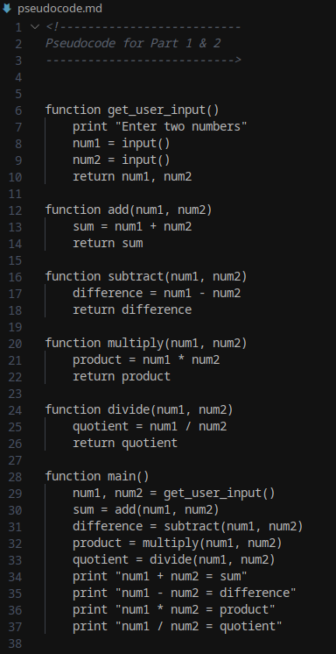

**Part 1 Source Code:**

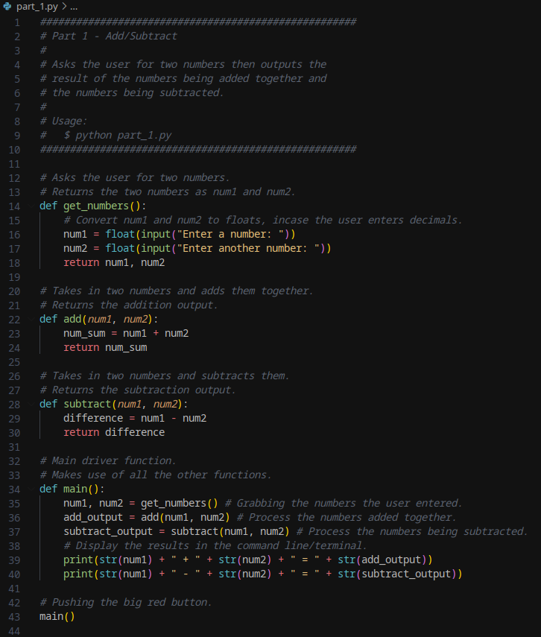

**Part 2 Source Code:**



**Part 1 & 2 Output:**

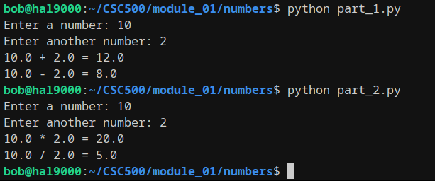

[**Github Repo**](https://github.com/rt75272/CSC500)**:**

https://github.com/rt75272/CSC500